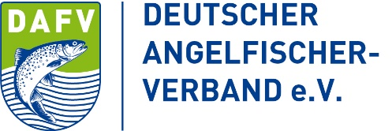 | 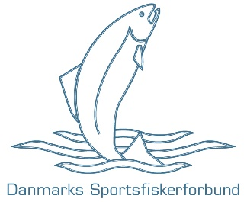 | 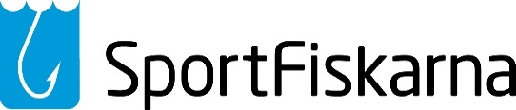

Concerning ICES advice for recreational fishing for Baltic salmon 2022.
  - Common position statement from Deutscher Angelfischerverband e.V. (Germany), Danmarks Sportsfiskerforbund (Denmark), and Sportfiskarna (Sweden) for Baltic Sea salmon 2022.

The International Council for the Exploration of the Sea (ICES) published its catch recommendations for salmon in the Baltic Sea (SD´s 22-31) on the 15th of September, for the year 2022. The advice from ICES contains suggestions for urgent measures to strengthen and protect weak river stocks by closing the mixed stock sea fishery, both recreational and commercial, and only allowing a limited coastal fishery within 4 nm in the Åland Sea, Gulf of Bothnia and Bothnian Bay (SD´s 29-31).

The national angler associations of Germany, Sweden and Denmark share ICES opinion that the current management strategy based on a mixed stock sea fishery with a single common MSY goal that encompasses all 37 wild river stocks cannot sufficiently protect individual salmon river populations. All current scientific information including the latest ICES advice shows clear problems for several river stocks and that the majority of weak salmon populations exist in assessment unit five in Poland, Lithuania, Latvia and Estonia. Together with ICES we believe that current management involves a risk for extirpation of several weak river stocks. We are therefore in agreement with ICES about the status of Baltic salmon and the need to change salmon management in the Baltic Sea region.

The European Anglers Alliance, national angling organisations and individual anglers have always been deeply involved in the health and wellbeing of our unique and iconic Baltic salmon. Angling organisations are actively involved in the restoration of rivers and invest large amounts of time, money, and energy into the goal of restoring rivers and salmon populations. Anglers have a vested interest in Baltic salmon and believe therefore it is important that change must occur in Baltic salmon management but believe that angling opportunities should be maintained. All anglers are well acquainted with, understand and respect regulations connected to their fishery including daily harvest limits (catch bag), closed periods and minimum size and slot limits. Angling keeps our members, a huge pool of voluntary labour, engaged in river restoration, water quality monitoring and fisheries control. This stakeholder involvement is essential if we are to keep European citizens involved and supportive in the wellbeing of salmon and also the environment in general.

Associated with the social importance of angler engagement is the economic importance of sea angling, so called trolling fishing, for coastal communities. Published research (Lewin et, al., 2021) has shown that in Germany alone salmon anglers spend 2 750 € per person and year, for a total expenditure of 5 million €, corresponding to 1 000 € per salmon removed. The EAA believes that sea angling for salmon, if regulated correctly, can have minimum effect upon river stocks while maintaining important regional economic activity.

Currently member states have differing regulations concerning minimum size limits and catch bags for salmon sea angling:
- Denmark, voluntary agreement of two salmon per person and day preferably adipose fin- clipped fish and minimum size of 75 cm
- Poland, two salmon per person and day, minimum size 60 cm.
- Finland, two salmon per person and day, minimum size 60 cm, 50 cm Bothnian Bay.
- Germany, three salmon per person and day with a closed season, minimum size 60 cm.
- Sweden, only adipose fin clipped fish (compensatory released salmon) and one fish per person and day.
- Latvia, one salmon per person and day, minimum size of 65 cm.
The national angling associations of Germany, Denmark and Sweden are of the opinion that a harmonization and general reduction in the catch bag for salmon at sea will have a positive impact on salmon stocks while maintaining the ability for European citizens to fish for salmon at sea.

The signatory national angler associations would like to underline that of equal importance to fisheries management actions are activities to allow for free migration in rivers of salmon, both up and downstream and actions to prevent overexploitation by predators.
All migrating fish have problems with small scale hydropower, disused mills, weirs, and other obstructions. If we are to reach our common goals for salmon smolt production and thereby grow both the commercial coastal fishery and realise the huge economic potential of sportfishing for salmon, then we must together prioritise removal of barriers for fish migration. We therefore strongly support the EU Biodiversity Strategy 2030 goal of restoring to free flowing at least 25 000 km of rivers.
Another significant issue for weak populations has been the exponential growth of cormorant predation within rivers and estuaries. Research conducted by the Danish Institute of Aquatic Resources (DTU Aqua) shows mortality of wild salmon by cormorants of over 50% (Baktoft et, al., 2008) during several consecutive years in salmon rivers. Predation of large numbers of salmon in a very short time by large flocks of migrating birds can be especially problematic as this is difficult to solve on a local or even national level.

These are the suggestions from the Deutscher Angelfischerverband e.V. (Germany), Danmarks Sportsfiskerforbund (Denmark), and Sportfiskarna (Sweden) concerning Baltic salmon regulations for 2022.

- A catch bag of one salmon per angler and day for sea anglers in SD´s 22-31.
- A common minimum size limit for salmon angling at sea.
- Utilise more EMFAF funding for the removal of fish migration barriers.
- A Baltic program should be initiated to achieve a balanced regional management of cormorants.

